Things that suck // Desert Fox

Preface
This tutorial explains how to make players get sucked into a fan, air duct, and how to play around with gravity in a zone to spice up you levels (although doing this is sort of a novelty...) Anyway...I assume that you have a level and something that is supposed to suck, but dosn't...(the rest of the level shouldn't SUCK but this one part should :)
Ok, to make your sucking fan, all you have to do is play around with gravity! I'm just going to use pictures from the level I'm working on now to show you how to do this, so you wont see a fan in the screens.
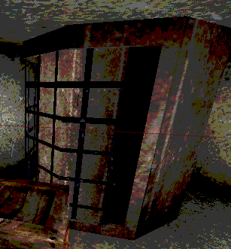
Say I want to make the player get sucked through this grating when they walk by it. All I have to do is set up a lateral gravity zone. (???) This means i make a zone that the gravity pulls you sideways.
Follow the numbers:
(1)I make a brush the size of the sucking area. (2) I click add special and make the preset "Zone Portal" Don't worry about the texture, it wont be visible in game. (3) I hit "Add Special" and a big crazy square appears. (4) From the classes menu, I choose "Actor->Info->ZoneInfo" and add it somewhere inside my big crazy cube. I made the sides translucent so you can easily see inside. (5) I set the lateral gravity in the zones properties to pull you into the grating. (The value may be different according to your purposes. PLay with the X and Y value until you get the right effect.)
(1)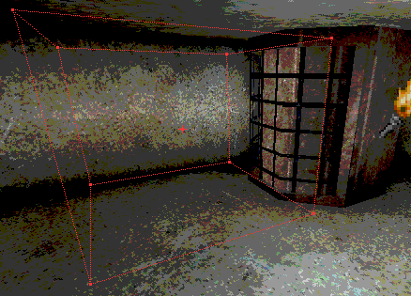
(2)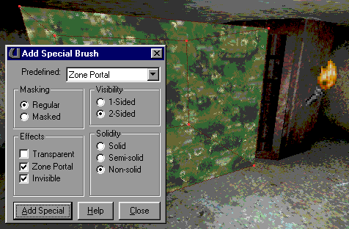
(3)&(4)
(5)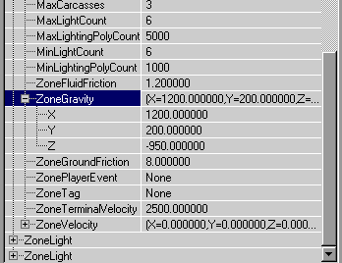
Get the right effect with your zone gravity, and you should be getting sucked laft and right by your crazy gravity zone. OH! And one more thing! Make sure that your zone brush touches the ground, preferably make it so it would envelope the entire player when he walks into it. If you don't do this, they will have to jump to get sucked in.

